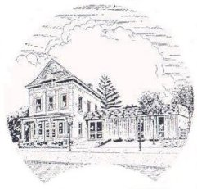
Talcott Free Library
101 East Main St
Rockton, IL 61072
www.talcottfreelibrary.com
Fax: 815.624.1176 ~ Phone: 815.624.7511

Volunteer Application
Name (First and Last): _____________________________________________________________
Address: __________________________________ City: ______________ Zip: _____________
Phone #: _______________________ Email: ___________________________________________
What is the best way to contact you? ______________________________
Age Category: Highest Education Level: Availability (list times):
____18-24 ____Grammar School Monday: __________
____25-39 ____High School Tuesday: __________
____40-54 ____Technical School Wednesday: __________
____over 55 ____Some College Thursday: __________
____prefer not ____College Degree in __________________ Friday: __________
to answer ____Professional Training in _____________ Saturday: __________
Why would you like to volunteer at Talcott Free Library?
_________________________________________________________________________________
Are you interested in joining the Talcott Free Library Friends Group? Yes _____ No______
Are you required to participate in a volunteer program? Yes______ No______
If yes, please explain: _______________________________________________________________
Do you have any physical limitations restricting your activities? Yes______ No______
If yes, please explain: _______________________________________________________________
Please mark all tasks/interests that pertain to you:
_____ art design _____ clerical/office work Computer Skills:
_____ crafts/cutting _____ used book sales _____ data entry
_____ filing _____article/photo archiving _____eReader/tablet
_____dusting _____ photocopying _____ word processing
_____shelf straightening _____shelf reading _____ spreadsheets
_____book withdrawals _____ book repair _____digital imaging
Software you use: _________________________________________________________________

